

Functional Specifications

Final Project

Contents

Requirements 3

Users 3

Admin Functionality 3

Terminology 3

Unregistered Users 4

Registered Users 5

# Requirements

1. Internet Connection
2. Web Browser

# Users

1. Registered Users
2. Unregistered Users

# Admin Functionality

There is no Admin Functionality currently

# Terminology

1. Badges – Identifies if the food matches a dietary restriction or Allergy Contents

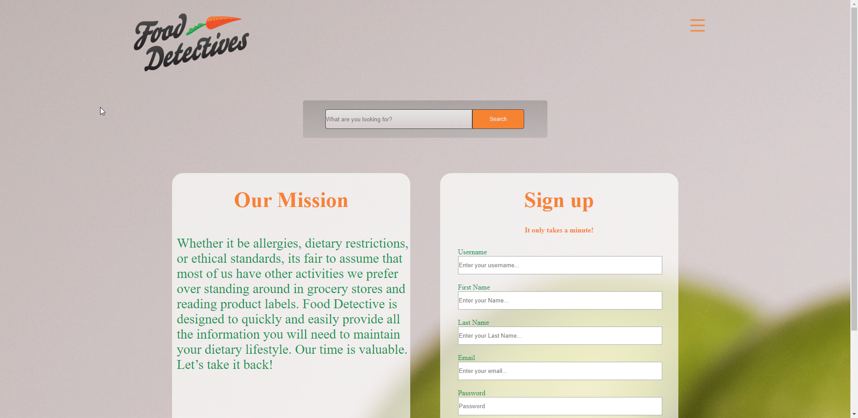

# Unregistered Users

Limited Functionality

1. Basic Search

Insert Screenshot of Basic search here

1. View Diet Badges
2. View Allergy Badges

Insert Screenshot of Basic search results here

# Registered Users

Full Functionality

1. Create New Account

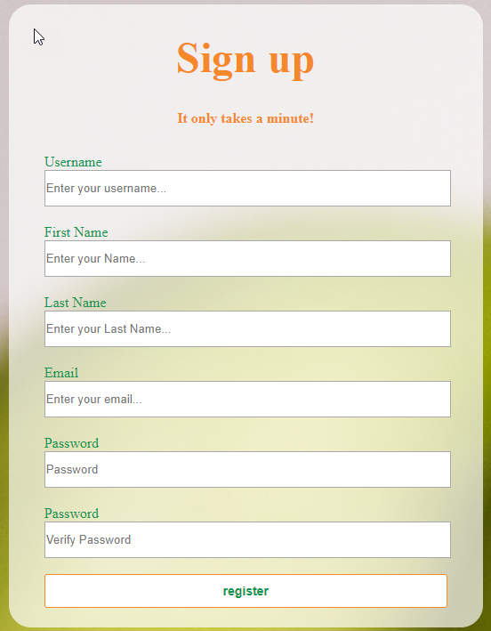

1. Sign in/Sign Out

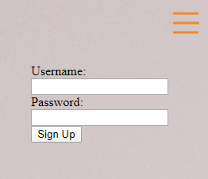

1. Add Dietary Preferences to streamline Badges
2. Advanced Search

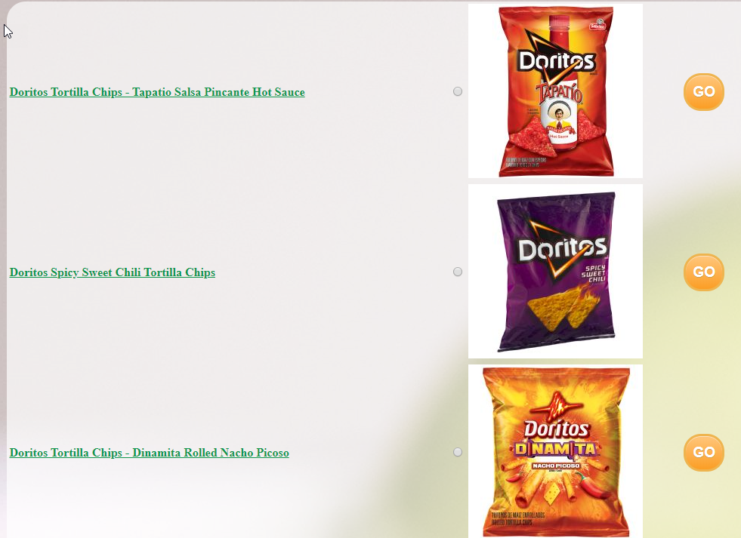

1. View Dietary Badges
2. View Allergy Badges
3. View Dietary Macros commonly shown on food labels

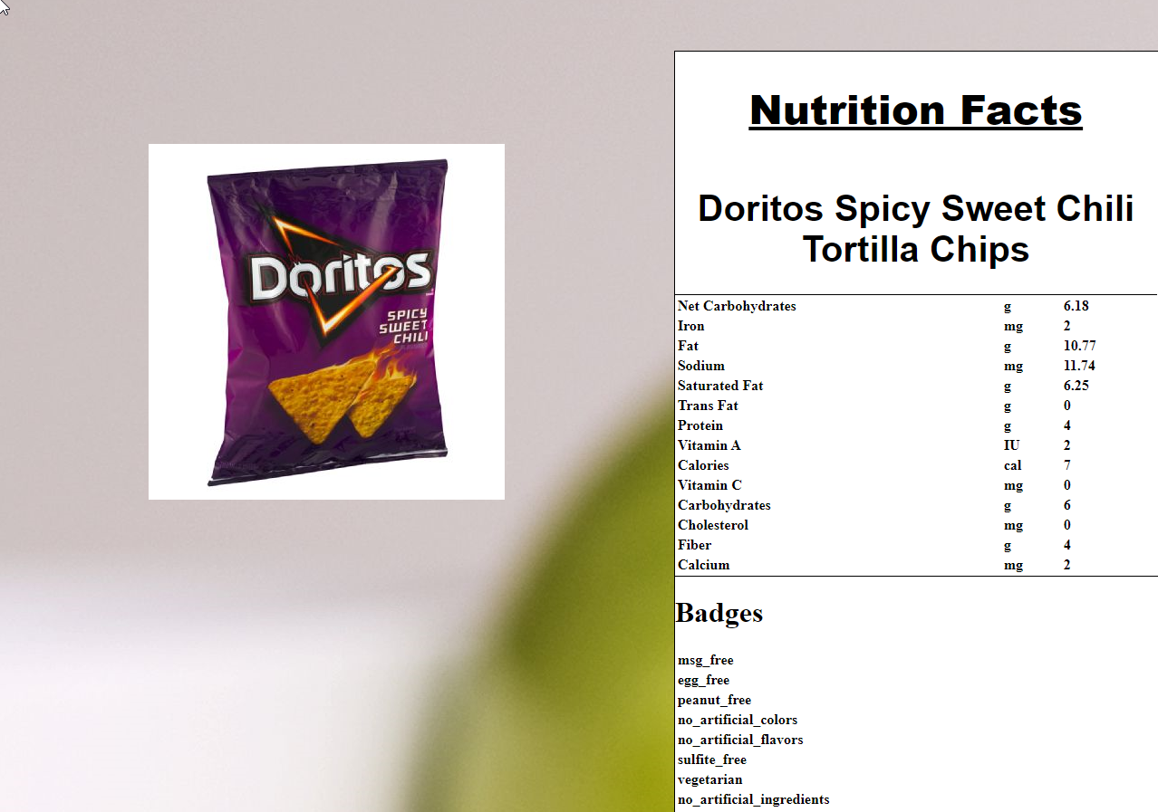

1. Add Favorite Foods to quickly access